Name_______________________ Date: ___________________ Period: ___
ACTIVITY 17-1: BULLET TRAJECTORY
Directions: Complete the steps of the activity listed in your textbook. Refer to the photographs and diagrams in your textbook for information. Show your work and write your answers in the spaces provided.

Scenario 2

Scenario 3
Part A

Part B Using the next diagram, determine the correct window.

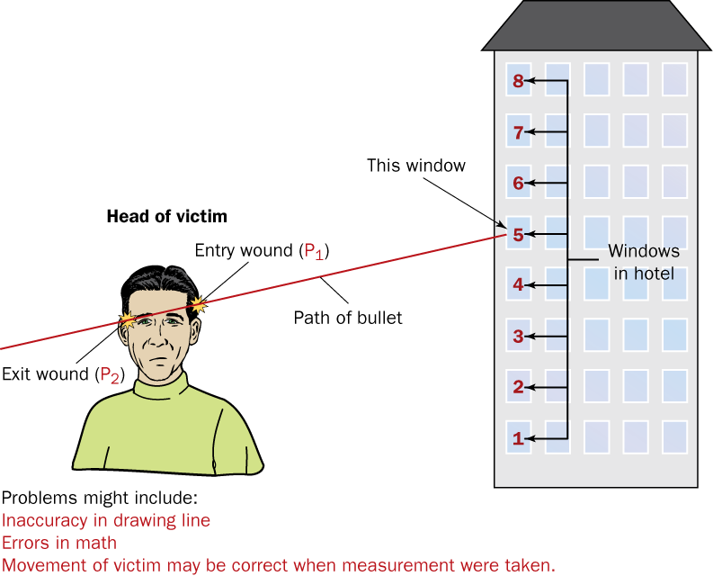

Bullet was fired from which window?___________________

Final Analysis
1. List problems that might interfere with the accuracy of your results.

2. What problems would be encountered if we couldn’t accurately determine trajectory angle?

Solve the following:

3. Angle of entry = 15° distance to building 700 feet
Height of shooter ~_____ feet
4. Angle of entry = 27° distance to building 60 feet
Height of shooter ~_____ feet
5. Angle of entry = 35° distance to building 85 feet
Height of shooter ~_____ feet

